Portfolio Milestone 6 Online Shopping Cart-

References:

[1] Lutz, M. (2013). Learning Python (5th ed.). O'Reilly Media. ISBN: 978-1449355739.

[2] Python Software Foundation. (2023). Python 3.9.1 documentation - Classes. Retrieved from https://docs.python.org/3/tutorial/classes.html

[3] W3Schools. (2023). Python Classes/Objects. Retrieved from https://www.w3schools.com/python/python_classes.asp
[4] https://learn.zybooks.com/zybook/CSUGLOBALCSC500MASTER1/chapter/8
[5] https://learn.zybooks.com/zybook/CSUGLOBALCSC500MASTER1/chapter/6

Few interesting learnings while preparing for and writing code for this project-

Lists in Python are dynamic arrays, meaning they can grow or shrink in size as needed. This makes them ideal for situations where you don't know the number of elements in advance, such as when constructing an object that will hold a collection of items (like items in a shopping cart).

We can initialize a list in a constructor with parameters to provide initial values for the object's attributes. If the list should be empty at the start, we can initialize it as an empty list using [] ( like the cart_items )

I also learned about the main() function in Python. In Python, the main function isn't a built-in concept like it is in some other programming languages, such as C or Java. However, it's a convention that's often used in Python scripts to denote the entry point of a program. The main function is typically used to organize the flow of execution in a script, making it more structured and readable.

The if __name__ == "__main__": check is used to determine if the script is being run directly or being imported as a module into another script. When the script is run directly (for example, by executing python script.py on the command line), the __name__ variable is set to "__main__", and the code inside the if block will execute, calling the main function.

Pseudocode-

Class ItemToPurchase:
Declare item_name as String
Declare item_price as Float
Declare item_quantity as Int

Method __init__(item_name="none", item_price=0, item_quantity=0):
Set self.item_name to item_name
Set self.item_price to item_price
Set self.item_quantity to item_quantity

Method print_item_cost():
Calculate total_cost as item_price * item_quantity
Print item_name, item_quantity, item_price, and total_cost

Class ShoppingCart:
Declare customer_name as String
Declare current_date as String
Declare cart_items as List of ItemToPurchase

Method __init__(customer_name="none", current_date="January 1, 2020"):
Set self.customer_name to customer_name
Set self.current_date to current_date
Initialize self.cart_items as an empty list

Method add_item(ItemToPurchase):
Append ItemToPurchase to cart_items

Method remove_item(item_name):
For each item in cart_items:
If item's name matches item_name:
Remove item from cart_items
Return
Print "Item not found in cart. Nothing removed."

Method modify_item(ItemToPurchase):
For each item in cart_items:
If item's name matches ItemToPurchase's name:
Update item's price and quantity from ItemToPurchase
Return
Print "Item not found in cart. Nothing modified."

Method get_num_items_in_cart():
Declare num_items as Int and set to 0
For each item in cart_items:
Add item's quantity to num_items
Return num_items

Method get_cost_of_cart():
Declare total_cost as Float and set to 0
For each item in cart_items:
Add item's price * quantity to total_cost
Return total_cost

Method print_total():
Print customer_name, current_date, and number of items in cart
If cart_items is empty:
Print "SHOPPING CART IS EMPTY"
Else:
For each item in cart_items:
Call item's print_item_cost method
Print total cost of cart

Method print_descriptions():
Print customer_name, current_date, and "Item Descriptions"
For each item in cart_items:
Print item's name and quantity

Method print_menu(ShoppingCart):
Declare command as String
While command is not "q":
Print menu options
Get user input for command
If command is "a":
Prompt for item_name, item_price, item_quantity
Call ShoppingCart's add_item method
Else If command is "r":
Prompt for item_name
Call ShoppingCart's remove_item method
Else If command is "c":
Implement change item quantity functionality
Else If command is "i":
Call ShoppingCart's print_descriptions method
Else If command is "o":
Call ShoppingCart's print_total method
Else If command is "q":
Print "Quitting..."
Else:
Print "Invalid option, please try again."

Method main():
Create ShoppingCart instance with default or user-provided values
Call print_menu with ShoppingCart instance

Call main() if script is run directly

Source code –

Below are the screen shots of the source code

I have added the link to my .py file and uploaded as well.
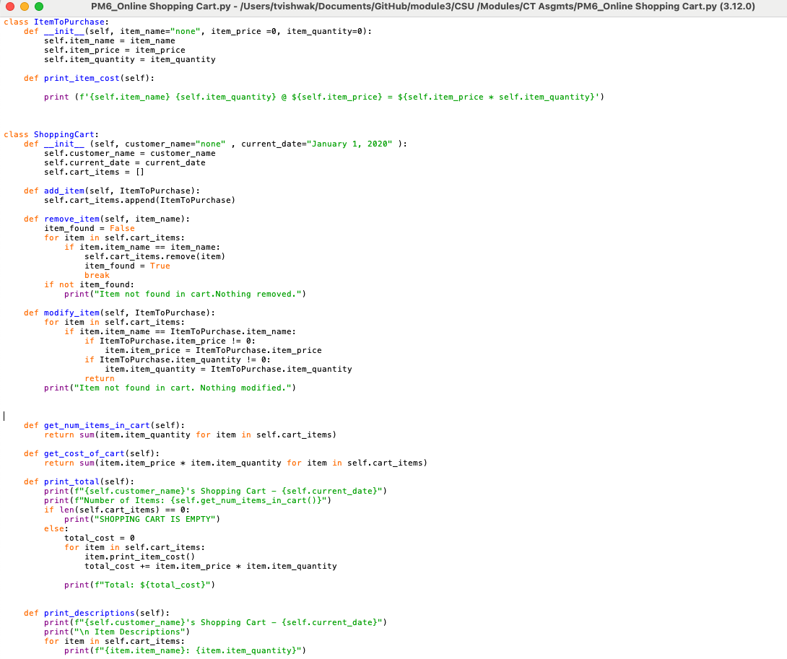

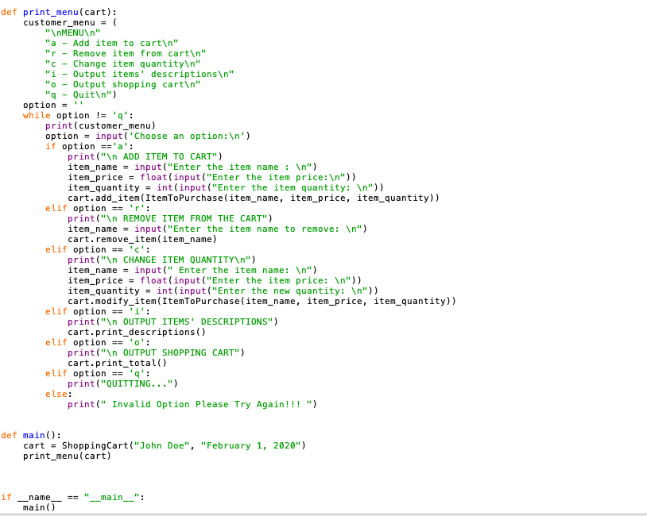

Screen Shots of the Executed code with errors and fixes-

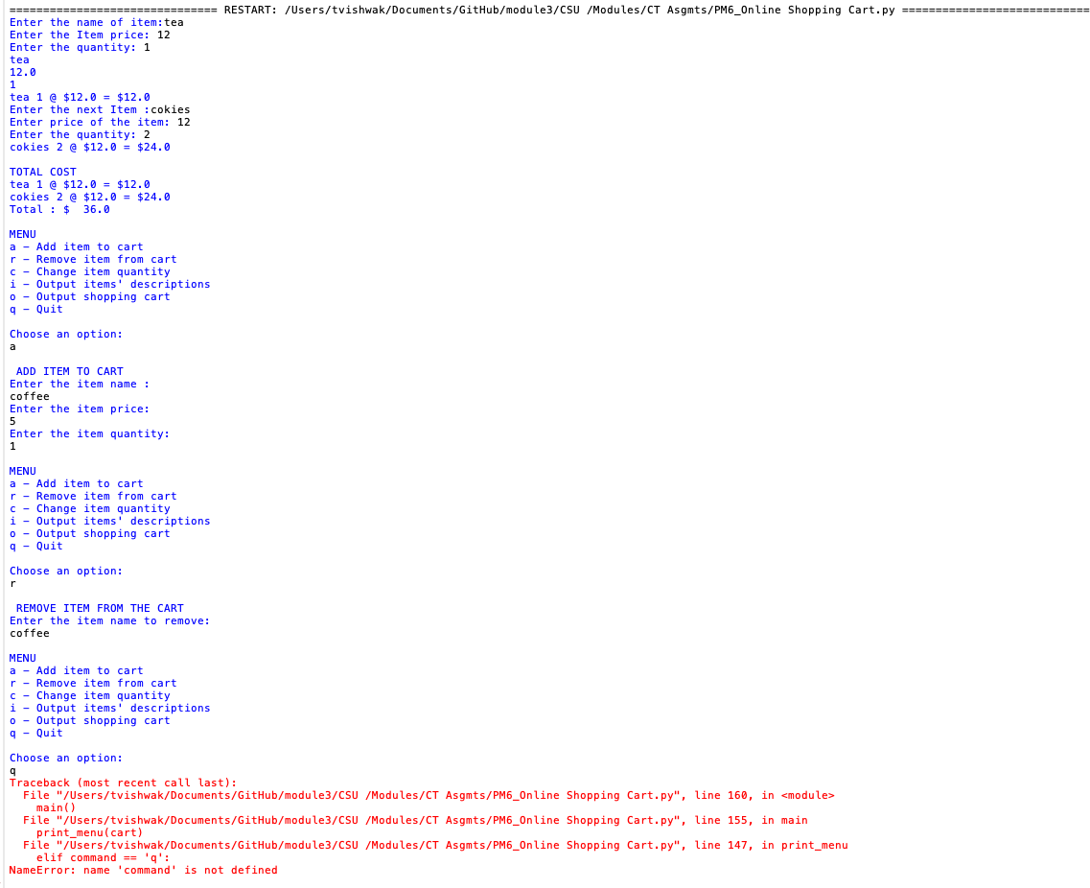

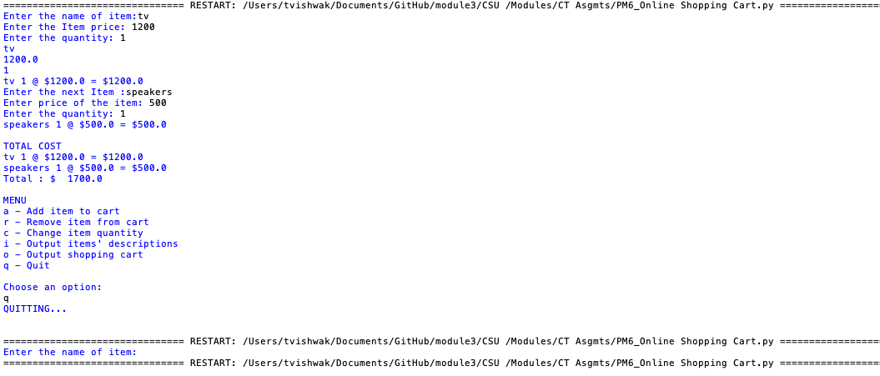

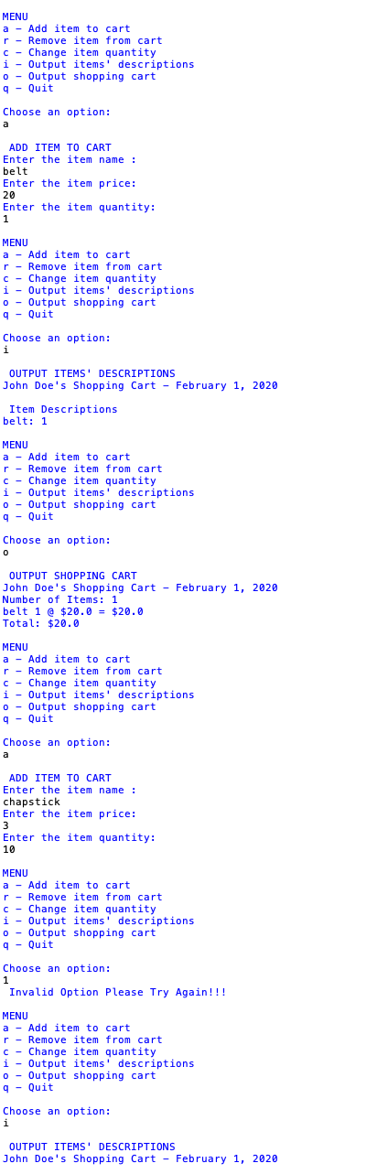
Successful execution of all the methods “options” , in the MENU
